The Pinetree Pledges
As a proud member of the Unity Education Trust we adopt The Unity Pledges. We want all of our pupils to leave us having had a varied educational experience that prepares them both academically and emotionally for their Next steps. We interweave the Unity Pledges into our life skills curriculum which allows pupils to work on their SEMH needs.
Our life skills learning is separated into 3 topic areas:
Communication and oracy
Creativity and emotional literacy
Resilience and perseverance
In each one pupils learn skills they will be required to have both whilst at school and when they enter the world of work and post 16 Education. The life skills topics are inspired by our thirst to get pupils to behave better, attend better and achieve better.
Life skills allows pupils the chance to experience trips and engage with lifelong educational experiences which they previously wouldn’t have been able to access. Curriculum leaders and class teachers take every opportunity to embed the Unity Pledges into their lessons .

Some examples of Untiy pledges.
Achieve Economic Well-Being

- Life skills budgeting and developing a meal for another person
- RSHE budgeting work – understanding the cost of activities
- Enterprise DT project and upcycling
- Taking part in charity fundraising events for Ukraine Appeal and Red nose day
- Understand price rising throughout the queen’s reign
Learning to earn money for rewards
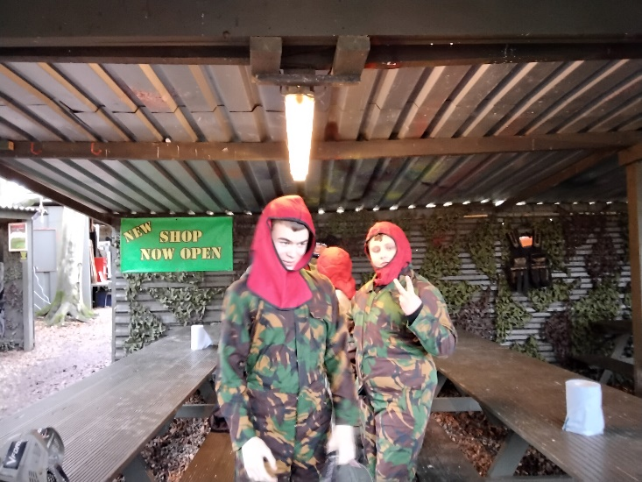

Enjoy and Achieve
Cultural Capital

- Crazy golf head-to-head competition
- BikeArt
- Afterschool football club
- Reading enrichment sessions
- Whole school jubilee tea party
- Taking part in World Book day
Learning a new skill - Archery

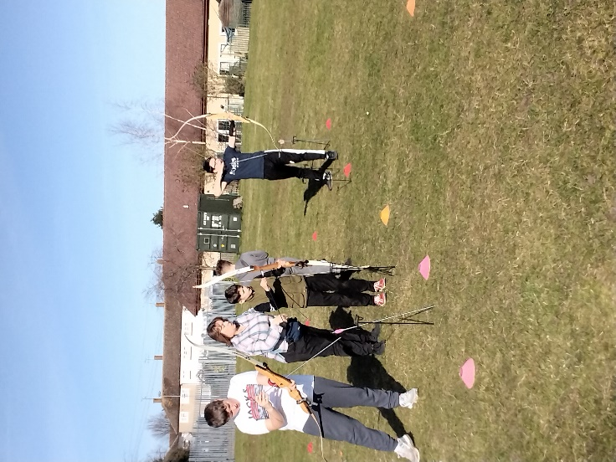

Climbing at Eaton Vale
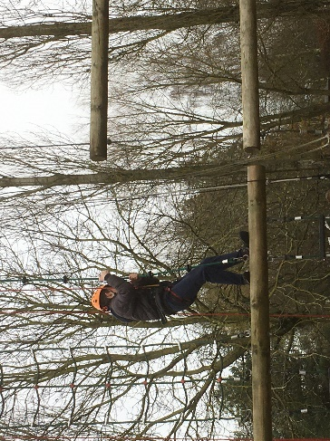
Create and play a game the whole can enjoy
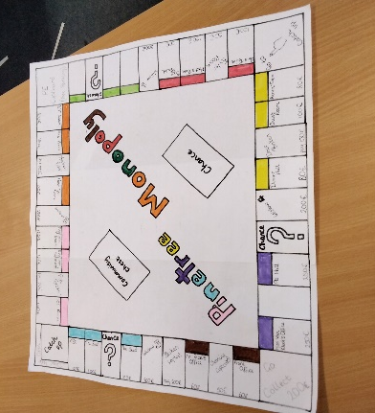
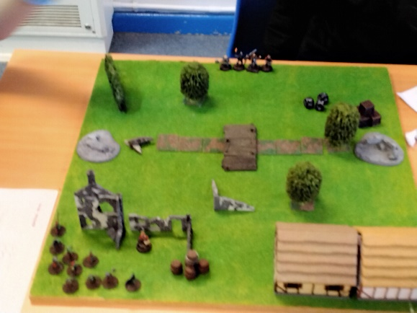

Be Healthy
Personal development

- Canoeing and biking
- FT – understanding a healthy plate
- PE lessons and lunch time clubs for PE, reading and DT

Resilience and perseverance trip to high lodge
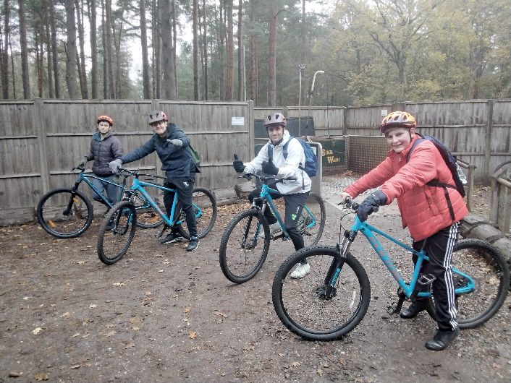

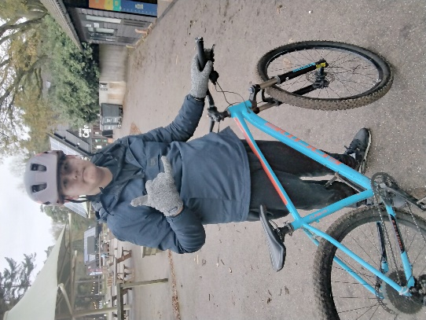

Canoe Trip
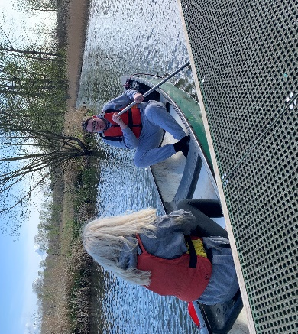
Healthy plate and learning to cook
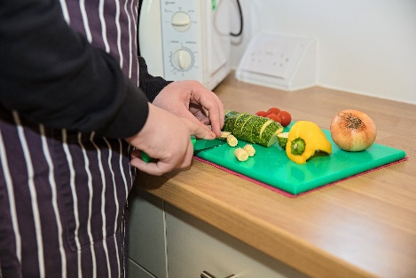

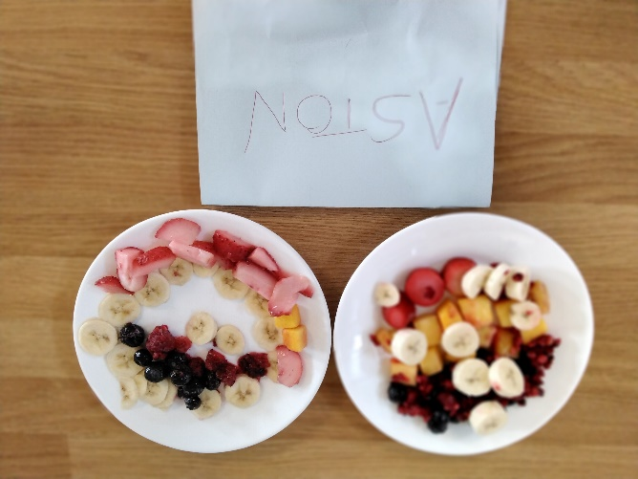

Make a Positive Contribution
Cultural Capital
- Work on the school garden
- Charity events
- Preparing activities for others to enjoy
- School council meeting
Support community garden projects
Planning Christmas meal for everyone to enjoy
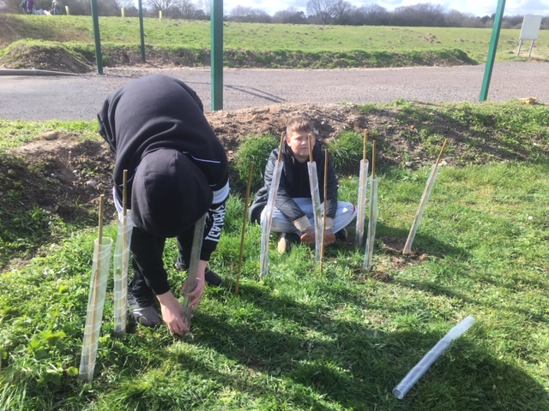
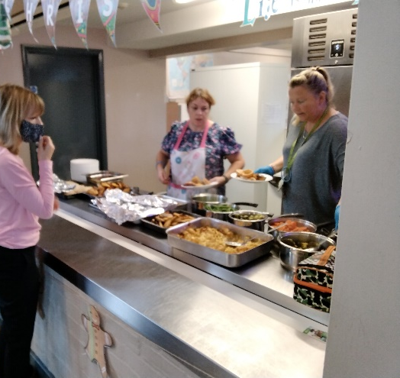
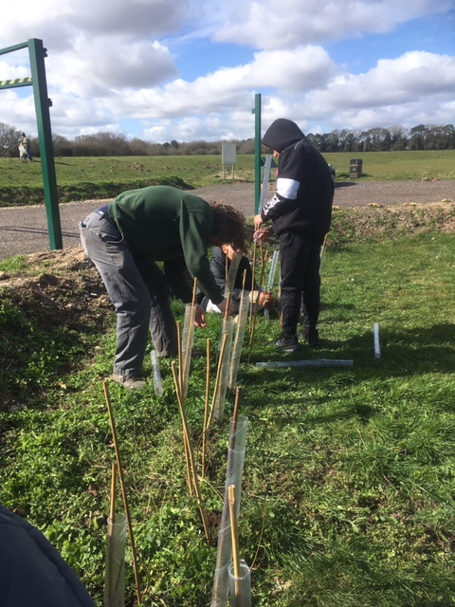

Supporting and maintaining our own school garden

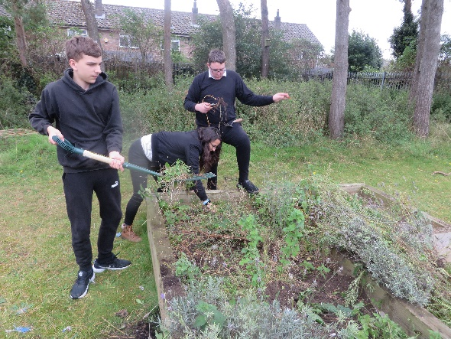
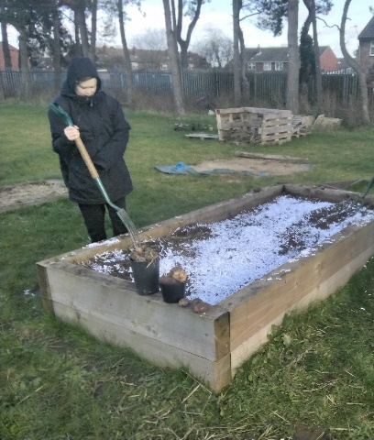
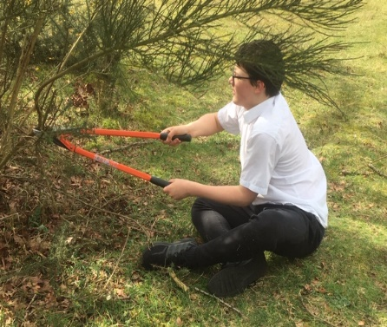

Charity events involvement

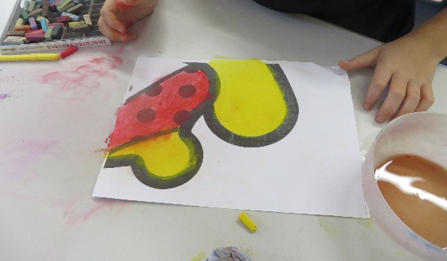

Stay Safe - Personal Development
- Police visit on Internet safety
- Explicit E-safety teaching
- Survival scheme – den building, camping and using a camp fire
First Aid Training for pupils
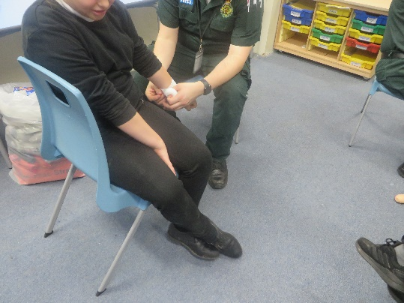
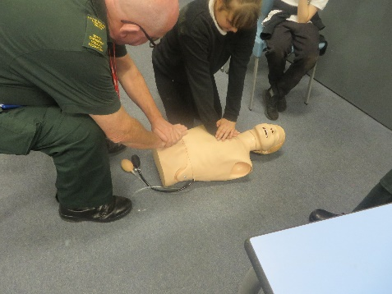
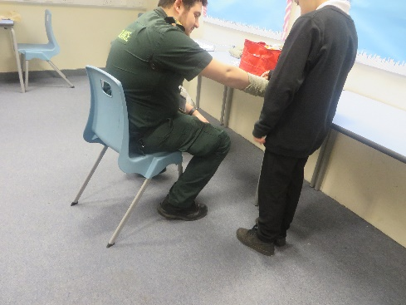

Understanding dangers of the world around us

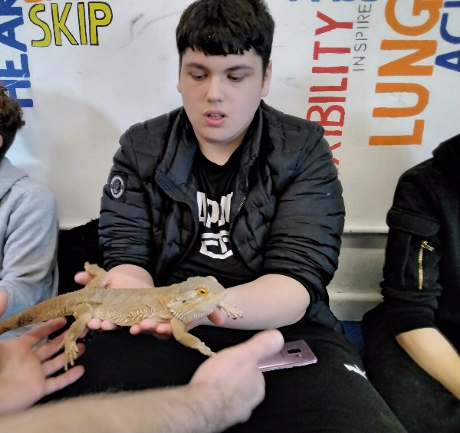
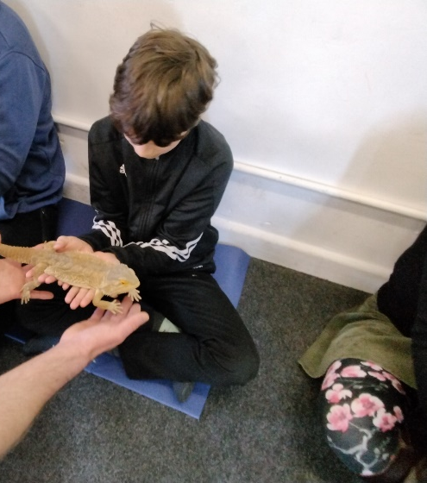
Surviving on your own
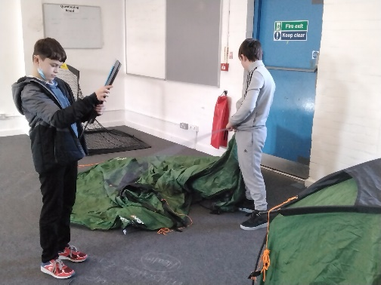
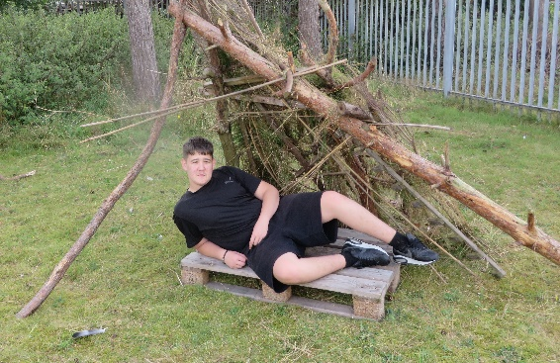
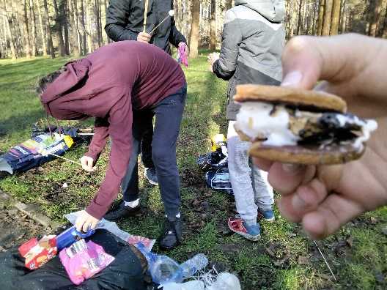
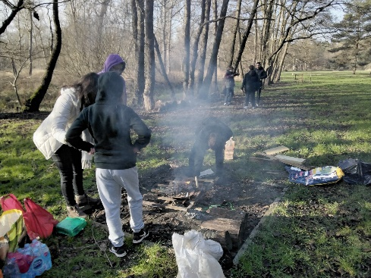
School survival unit

